EAD CA2 PROJECT

C & S FACILITIES MANAGEMENT

**April 3, 2018**

*Project Team: Carole van Damme / Suzanne Jones*

**PROJECT AIM AND SCOPE**

C&S Facilities Management provide meeting room booking services to client companies. They require a web service to manage meeting rooms and room bookings.

System admin can create, update, delete meeting room data.

Users can view the characteristics of the available rooms e.g.. size, location, equipment.

Users can book a room within available time slots e.g. Mon – Fri, 8.00-18.00

Users can cancel or update their booking.

Users can view their future bookings.

**Project Schedule**

|  |  |  |
| --- | --- | --- |
| **Project Plan** | | |
| ***Week Commencing*** | ***Tasks*** | ***Status*** |
| 9th April | Upload Proposal to Moodle  Create Project Base  Push on GitHub  Create Classes– Models (Booking +Meeting Room)  Create Classes – Models (User/Authenticate)  Create Database (EF Code First) | Complete  Complete  Complete  Complete  Complete  Complete |
| 16th April | Define REST Service methods – Controllers  Define Index  Define About | Complete  Complete  Complete |
| 23nd April | Define CRUD Meeting Rooms   * See Meeting Rooms * Get Meeting Room Details * Create Meeting Room * Update Meeting Room * Delete Meeting Room * Check Room Availability   Define CRUD Bookings   * Index * View Bookings * Create Booking * Edit a Booking * Cancel a Booking | Complete  Complete |
| 30th April | Define Views | Complete |
| 7th May | Create Console App to call operation & display results of analysis  URI Addressing Scheme  Unit Testing | Complete  Complete  Complete |
| 14th May | Deploy on Azure  Finalise Documentation | Complete  Complete |

**Database Design**



**test Data**

|  |  |  |  |
| --- | --- | --- | --- |
| Room Name | Location | Size | Equipment |
| North Wall  Royal Canal  Grand Canal  River Liffey | One Spencer Dock | 20  18  8  4 | **Wi-Fi Projector VC WB**  Wi-Fi Projector VC WB  **Wi-Fi VC WB**  **Wi-Fi Conf Phone** |
| Guild Street  Sheriff Street  Point Village | Two Spencer Dock | Theatre 50  Square 12  U-Shape 24 | **Wi-Fi Projector**  Wi-Fi Conf Phone WB  Wi-Fi Projector VC WB |

|  |  |  |  |  |  |
| --- | --- | --- | --- | --- | --- |
| UserID | Meeting Ref | Room Name | Day / Date | StartTime | EndTime |
| Jane Smith PWC | PWC May Board Meeting | North Wall | Tuesday, 15/5/18 | 9.00 | 17.00 |
| Paul Dunne Point | Point Management meeting | Sheriff Street | Monday, 14/5/18 | 15.00 | 17.00 |
| Ben Jones RG5 | RG5 Weekly Sales Meeting | Point Village | Friday, 18/5/18 | 11.00 | 14.00 |
| Michelle Ryan PWC | PWC Staff Briefing | Guild Street | Wednesday, 16/5/18 | 9.00 | 15.00 |
| Jane Smith PWC | PWC Michael O’Neill | River Liffey | Tuesday, 15/5/18 | 15.00 | 16.00 |
| Shane Kelly Point | Point Events Review | Grand Canal | Wednesday, 16/5/18 | 9.00 | 17.00 |
| Mark Duggan Gibson | Gibson Client x569 booking | Guild Street | Thursday, 17/5/18 | 10.00 | 18.00 |
| Jane Smith PWC | PWC Audit Partner Induction | Grand Canal | Monday, 14/5/18 | 10.00 | 15.00 |
| Mark Duggan Gibson | Gibson Client x453 booking | Sheriff Street | Thursday, 17/5/18 | 13.00 | 18.00 |
| Shane Kelly Point | Point Strategy Review | Royal Canal | Friday, 18/5/18 | 14.00 | 18.00 |

|  |  |  |  |
| --- | --- | --- | --- |
| **User Testing** | | | |
| Test | Expected Outcome | Actual Outcome | |
| Pass | Fail |
| **Tests: System Admin: Test Logon Azure**  **Type: Admin / Email** [**s.admin@gmail.com**](mailto:s.admin@gmail.com) **/ Password Admin88!** | | | |
| Register with first name and last name | Register successfully (Note: add manually to Admin role in table) | Register successfully | |
| Login | Login successfully | Login successfully. Register changes to “Welcome Lilla Fog” Logon changes to Logoff. | |
| Read Meeting Room - verify data | Can access & view Meeting Room tab | Can view all rooms for all users | |
| Create Meeting Rooms | Cannot create if another room with same name exists  Can create meeting room if name doesn’t already exists | Cannot create a meeting room of the same name. Error Message: “A meeting room with the same name already exists”  Can create meeting room if name doesn’t already exists | |
| Update Meeting Room - change data and check data update | Cannot update if another meeting room has the same name  Can update meeting room to another name not already taken | Cannot update a meeting room of the same name. Error Message: “A meeting room with the same name already exists”  Can update meeting room to another name not already taken | |
| Delete Meeting Room - delete Meeting Room and check data update | Cannot delete if a meeting is happening in that room in the future  Can delete a room if no future booking | Cannot delete if a meeting is happening in that room in the future Error Message: “This meeting room cannot be deleted as it has been booked for future meetings”  Can delete a room if no future booking | |
| View all future bookings for all users | Can view all future bookings for all users | Can view all future bookings for all users | |
| View meeting rooms details | Can view all meeting room details | Can view all meeting room details | |
| Find room for booking | Only if date in future + on weekdays + from 8am to 6pm | Find available rooms  Error Message displayed if picked date in the future or on a weekend  Drop-down only give option to book from 8am to 6pm | |
| Book a room | Only if not already booked | Will only offer un-booked rooms so cannot book already booked room | |
| Update a booking for any user | Admin can see and update any user bookings | Admin can see and update any user bookings | |
| Delete a booking for any user | Admin can delete other user bookings | Admin can delete other user bookings | |
| Logoff User | User Logoff | User Logged off. Welcome user name changes to Register & Logoff changes to Logon | |
|  | | | |
| **Tests: User Logon Azure**  **Type: User / Email** [**s.user@gmail.com**](mailto:s.user@gmail.com) **/ Password User18!** | | | |
| Access Home page unlogged |  |  | |
| Access About page unlogged |  |  | |
| Register |  |  | |
| Login |  | Hello Sue Jones! message | |
| View all meeting rooms |  | User will be brought to a ‘find meeting room’ screen. | |
| Search for a meeting room by name |  | Can select required room from drop down if room not booked | |
| Order meeting room list by name and size |  | Click on Name or Size Columns to sort a-z or numerically | |
| Cannot create, edit or delete a meeting room |  | User cannot create, edit or delete a meeting room – options cannot be seen | |
| View only own future bookings |  | User can only see their future bookings | |
| View meeting room details on booking |  | Can click on Room Name to see further room details on size, location etc | |
| Book a room that’s free |  | Only free rooms offered for booking. | |
| Search for room at same date and times as above, room list should display all rooms except the one booked above |  | User is not offered already booked room from above | |
| Get an error if trying to book a room already booked |  | User cannot book a room that is already booked. There is no error as user cannot even try booking booked room. | |
| Get an error if trying to book a room at weekend | Error message: Meetings cannot happen at the weekend. Please pick another date. | Error message: Meetings cannot happen at the weekend. Please pick another date. | |
| Try to book Grand Canal meeting room on 15/5/18 from 11.00-15.00 |  | No Error message: This room is not available for booking as already booked | |
| Try to book a room with an invalid user id | Error message: Invalid logon attempt but a new user can register a new logon | Error message: Invalid logon attempt but a new user can register a new logon | |
| Try to book a room that does not exist | You cannot pass the drop-down selection. | User can only see free rooms | |
| Try Book a room with incomplete or incorrect data | Error message: x data is required.  Please check start and end times. A meeting cannot end before it starts | Incomplete data not possible as data is pre-populated. Incorrect data: “Please check start and end times. A meeting cannot end before it starts”. | |
| Edit a Booking | Only if own booking and at valid dates and times and if room is free | User can only edit own bookings for future dates | |
| Cancel a Booking | Only if own booking | User can only delete own bookings for future dates | |
| Logoff |  | User Logged off. Welcome user name changes to Register & Logoff changes to Logon | |

**uNIT Testing RESULTS**

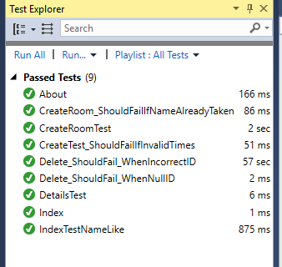

|  |  |  |
| --- | --- | --- |
| **URI Addressing Scheme** | | |
| **Action Type** | **Route** | **Purpose** |
| GET | [https://localhost:49682/](https://localhost:44369/) or [https://localhost:49682/Home/](https://localhost:44369/Home/) | Access the Home page |
| GET | [https://localhost:49682/Home/About](https://localhost:44369/Home/About) | Access the About page |
| GET | https://localhost:49682/Meeting Rooms | View all Meeting Rooms |
| GET | [http://imeet.azurewebsites.net/MeetingRooms?sortOrder=name_desc](https://localhost:44369/MeetingRooms?sortOrder=name_desc) | View all Meeting Rooms sorted by name descending |
| GET | [http://imeet.azurewebsites.net/MeetingRooms?sortOrder=Size](https://localhost:44369/MeetingRooms?sortOrder=Size) or [http://imeet.azurewebsites.net/MeetingRooms?sortOrder=size_desc](https://localhost:44369/MeetingRooms?sortOrder=size_desc) | View all Meeting Rooms sorted by size (ascending or descending) |
| GET | [http://imeet.azurewebsites.net/MeetingRooms/Details?keyword=Board%20Room](https://localhost:44369/MeetingRooms/Details?keyword=Board%20Room) | View details of Meeting Rooms with containing certain keyword |
| GET | [http://imeet.azurewebsites.net/](https://localhost:44369/)MeetingRooms/Create | A: Create Meeting Room GET |
| POST | [http://imeet.azurewebsites.net/](https://localhost:44369/)MeetingRooms/Create | B: Create Meeting Room POST |
| GET | http://imeet.azurewebsites.net/Meeting Rooms/Edit/5 | A: Edit/Change Meeting Room data GET with identifier 5 |
| POST | http://imeet.azurewebsites.net/Meeting Rooms/Edit/5 | B: Edit/Change Meeting Room data POST with identifier 5 |
| GET | http://imeet.azurewebsites.net/MeetingRooms/Delete/5 | A: View details of meeting room to delete for confirmation |
| DELETE | http://imeet.azurewebsites.net/Meeting Rooms/Delete/5 | B: Delete Meeting Room with identifier 5 |
| GET | [http://imeet.azurewebsites.net/Booking/Index](https://localhost:44369/Booking/Index) or [http://imeet.azurewebsites.net/Booking](https://localhost:44369/Booking) | View all bookings if admin user or view own bookings if regular users |
| GET | http://imeet.azurewebsites.net/Booking/Create | A: Find available rooms at a specific date and times |
| POST | [http://imeet.azurewebsites.net/Booking/CreateStep2](https://localhost:44369/Booking/CreateStep2) | B: Input booking title and select a room (POST view model) |
| POST | [http://imeet.azurewebsites.net/Booking/CreatePost](https://localhost:44369/Booking/CreatePost) | C: Create Booking POST |
| GET | [http://imeet.azurewebsites.net/Booking/Edit/5](https://localhost:44369/Booking/Edit/5) | A: Edit Booking data with identifier 5 (GET) |
| POST | [http://imeet.azurewebsites.net/Booking/Edit/5](https://localhost:44369/Booking/Edit/5) | B: Edit Booking data with identifier 5 (POST) |
| GET | http://imeet.azurewebsites.net/Booking/Delete/5 | A: View details of booking with identifier 5 for confirmation to delete |
| DELETE | http://imeet.azurewebsites.net/Booking/Edit/Delete/5 | B: Delete Booking with identifier 5 |
| GET | [http://imeet.azurewebsites.net/booking/GetAvailableRooms?_date=20180609000000&_startTime=20180609090001&_endTime=20180609100000](https://localhost:44369/booking/GetAvailableRooms?_date=20180609000000&_startTime=20180609090001&_endTime=20180609100000) | Get in Json format a list of meeting rooms available at specific date and times |

**Screenshots**

**Initial / Home Screen**

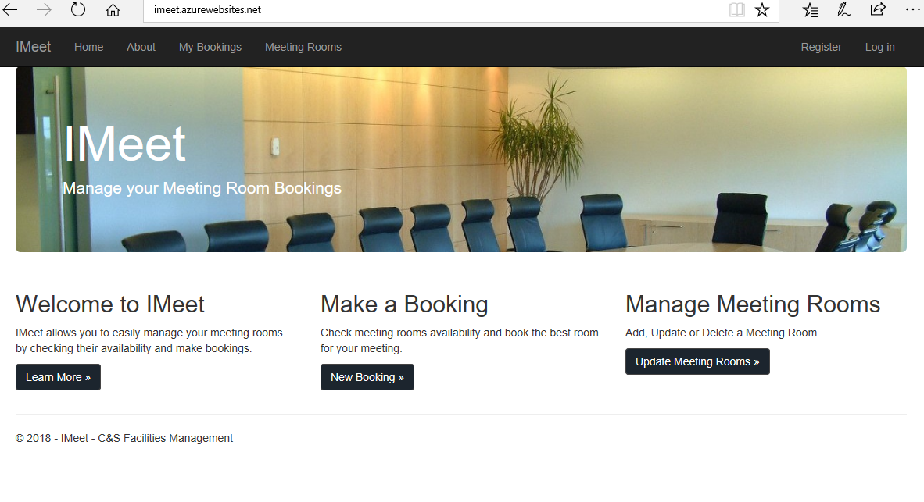

**About Screen / Welcome to IMeet – Learn More**

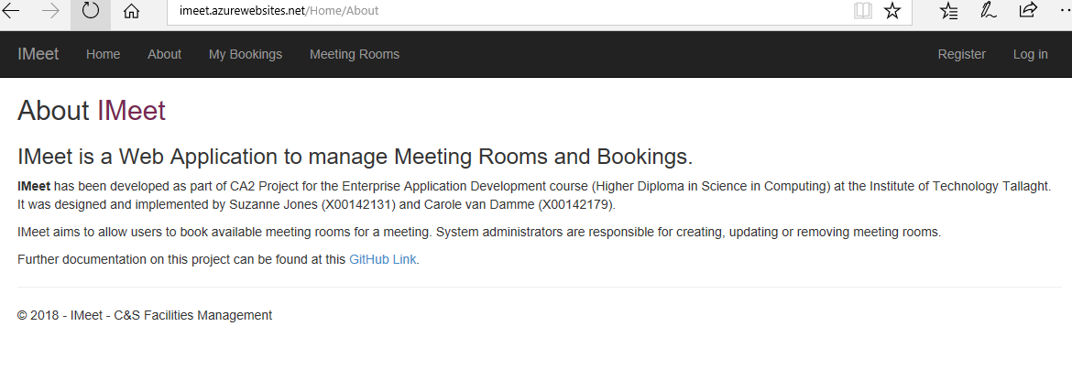

**My Bookings / View Future Bookings Screen – Initial Logon**

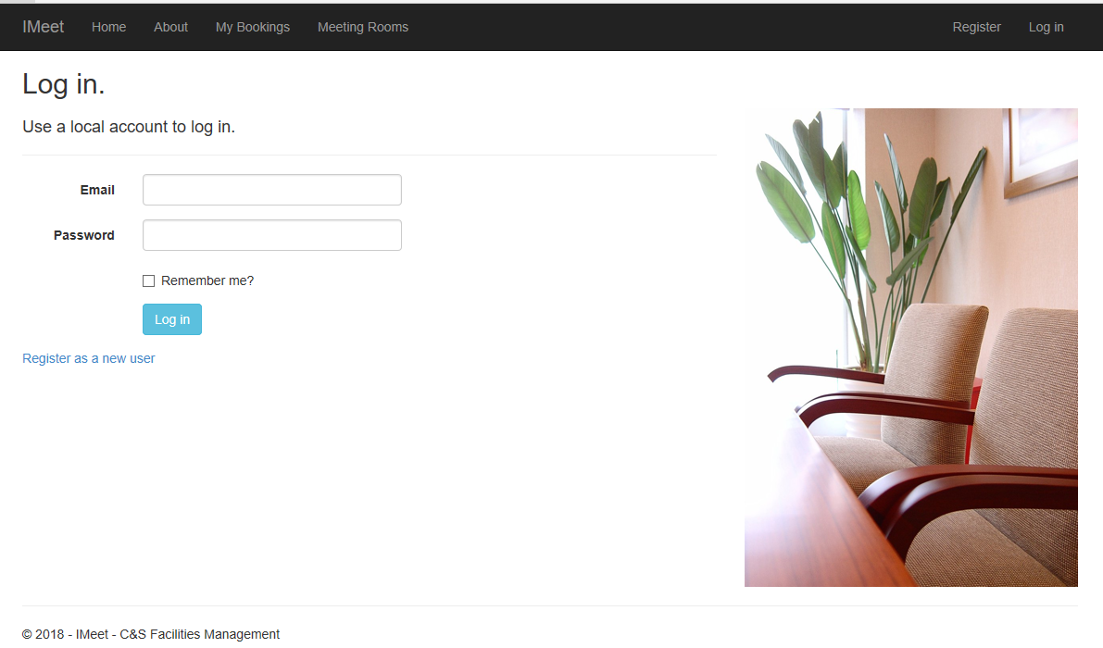

**My Bookings / View Future Bookings Screen - Can Create Booking / Edit / Cancel Room Booking from here**

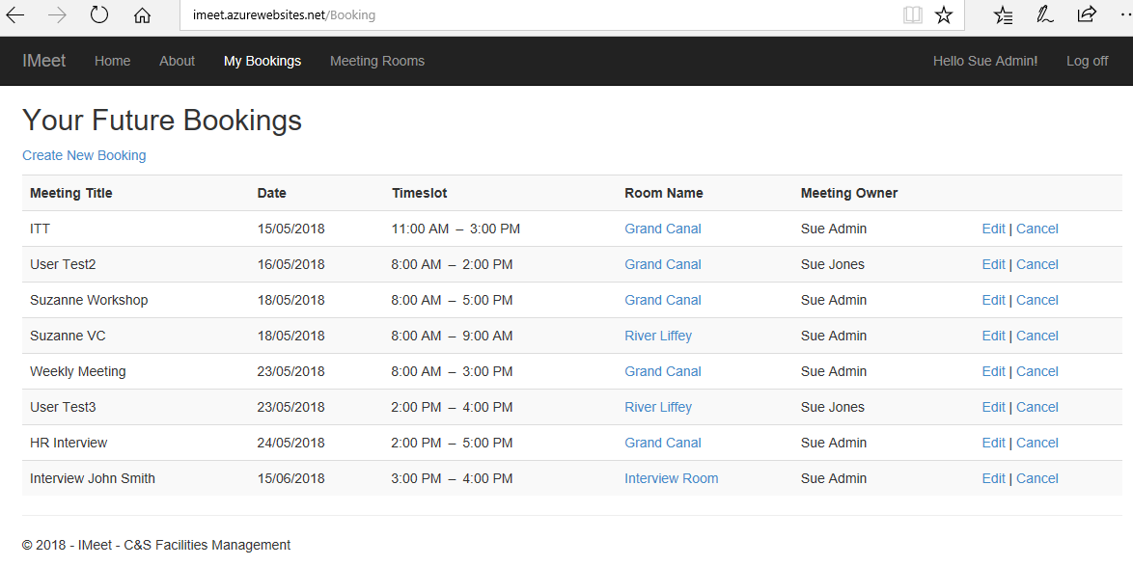

**My Bookings / View Future Bookings Screen / Create New Booking / Find Room – Select ‘Create Meeting’**

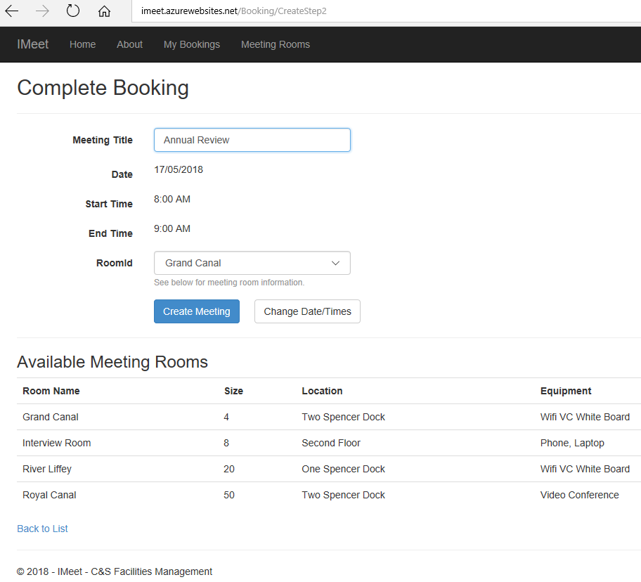

**Meeting Rooms Screen – Initial Logon**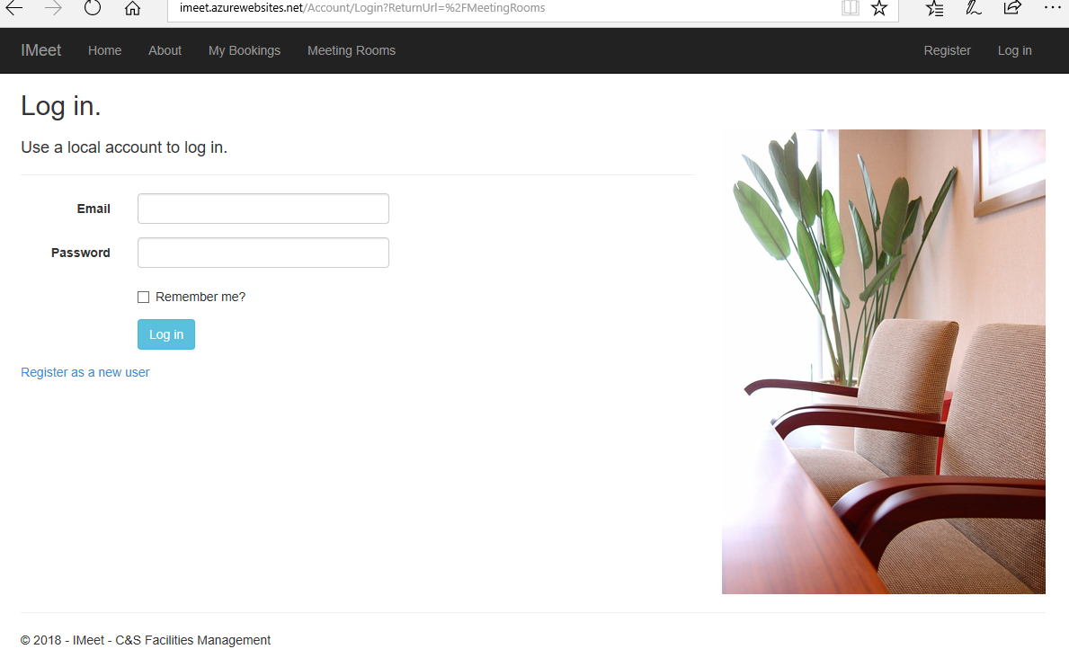

**Meeting Rooms Screen – After Logon.**

**An Admin user can add a new meeting room and Delete**

**A regular user can only see, edit and delete their own bookings**

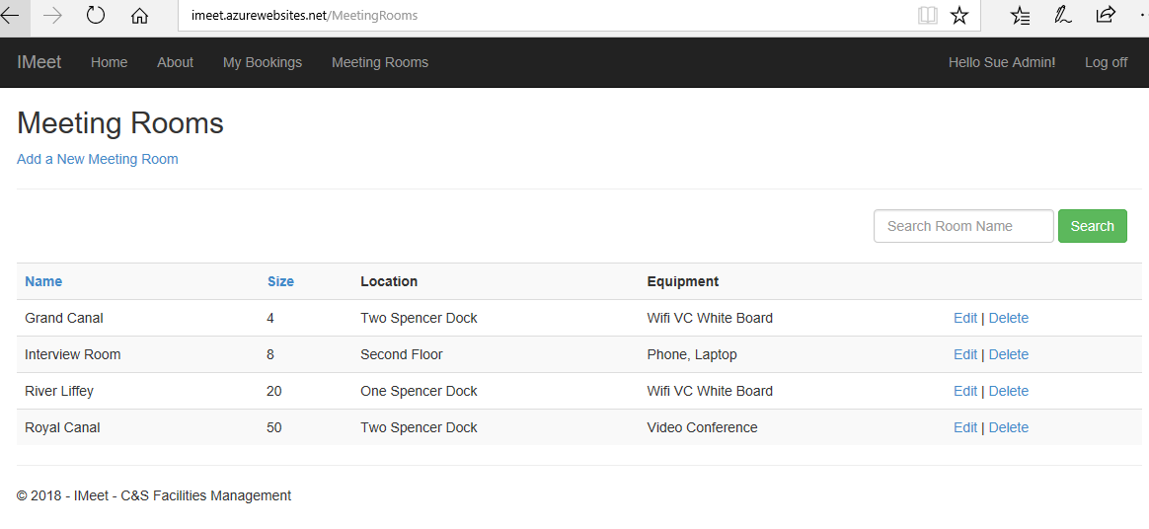

**Add a new Meeting Room – Select Create to Save * Admin task only**

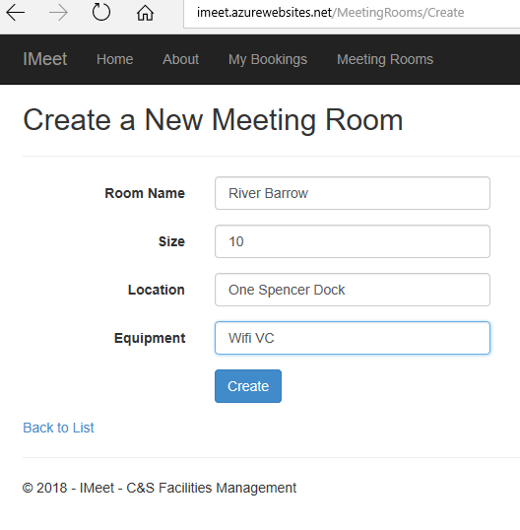

**Console Client App**

